Viruses

**Design Document**

|  |  |  |
| --- | --- | --- |
| **Supervisor.** | **Sir Ebad Uddin Ahmed** | |
| **Batch.** | **2210C2** | |
| **Group.** | **B** | |
| **Serial No.** | **Enrollment Number** | **Student Name** |
| 1. | 1424748 | Syed Zamin Abbas |
| 2. | 1424826 | Syed Abdul Hadi Ali |
| 3. | 1423493 | M Aqib Zubairi |
| 4. | 1424859 | Sheikh M Affan |

**ACKNOWLEDGEMENT**

Before anything, I would like to thanks my beloved teacher who helped us a lot in reviewing this project within the limited time frame. Secondly, we would also like to thank the eProject team at Aptech Head Office, who gave us the golden opportunity to do this wonderful project about Viruses.

Thirdly, we also thank the eProject team, some of the benefits are as under: Re-enforcement of skills happens in the experiential learning process. A mentor, ensuring that we do not get drifted, constantly guides us. ∙ It gives us a lot of confidence to face an interview as we have worked on a project.

***SYNOPSIS***

With the help of technology, we are providing awareness of viruses. Viruses have caused major damage to mankind. In recent times there are various Viruses which have attacked humans. The information about these viruses is scattered. There is need to develop a website with complete and relevant information about these viruses like; Corona Virus, Dengue Virus, Zika Virus, and Influenza Virus, etc.

***PROBLEM DEFINITION***

Another problem with human virus websites is that they can spread misinformation and conspiracy theories about viral infections, which can lead to fear, panic, and discrimination against certain groups of people. For example, during the COVID-19 pandemic, there have been numerous false claims made about the virus's origin, transmission, and treatments, which have fueled racism and xenophobia towards people of Asian descent.

***CUSTOMER REQUIREMENT***

***SPECIFICATION (CRS)***

The Website is to be created based on the following requirements.

1. The Home page must have well defined logo and image of the Virus.
2. Apart from home link, other links such as Feedback Form, contains Feedbacks from customers.
3. Online awareness of Viruses.
4. Images of Different types of Viruses.
5. Navigation must be maintained smooth.
6. Color combination must be precise and uniformity must be maintained.
7. Subscription form should be provided.

***SCOPE OF THE WORK (IN BRIEF)***

The website is to be developed for the Windows Platform using HTML5, JavaScript and bootstrap jQuery. The site should work well in all leading browsers including Chrome, Firefox etc. Our welcome page icon is re-directed to the main web page Ever essential content direct to relative content.

***AGGREGATED SITEMAP***

***SITEMAP ENGLISH***

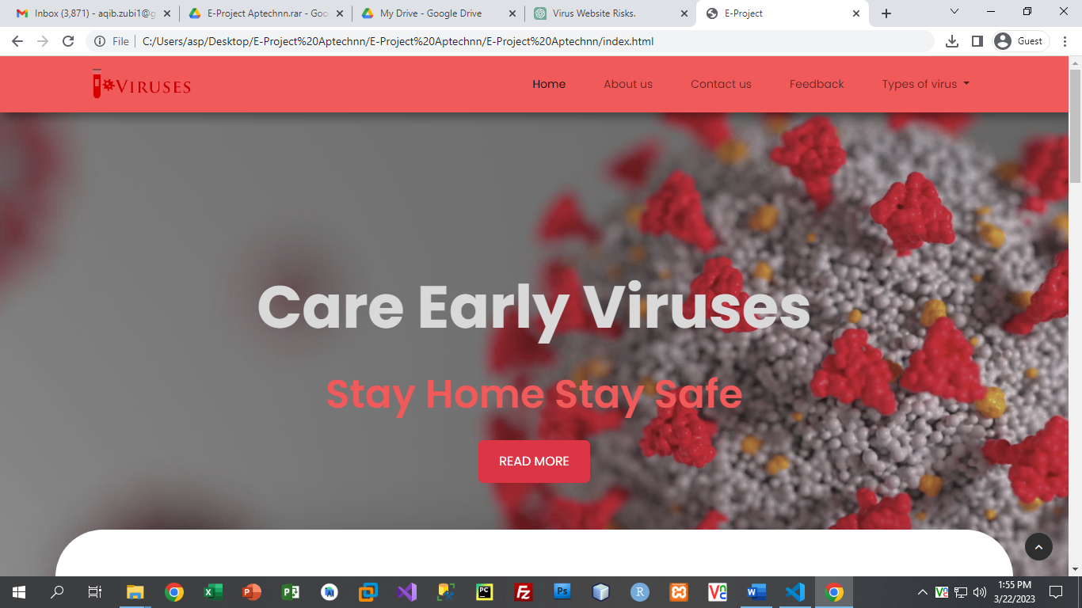

HOME

FEEDBACK US

FEEDBACK US

FEEDBACK US

FEEDBACK US

FEEDBACK US

FEEDBACK US

FEEDBACK US

FEEDBACK US



***WIREFRMES***

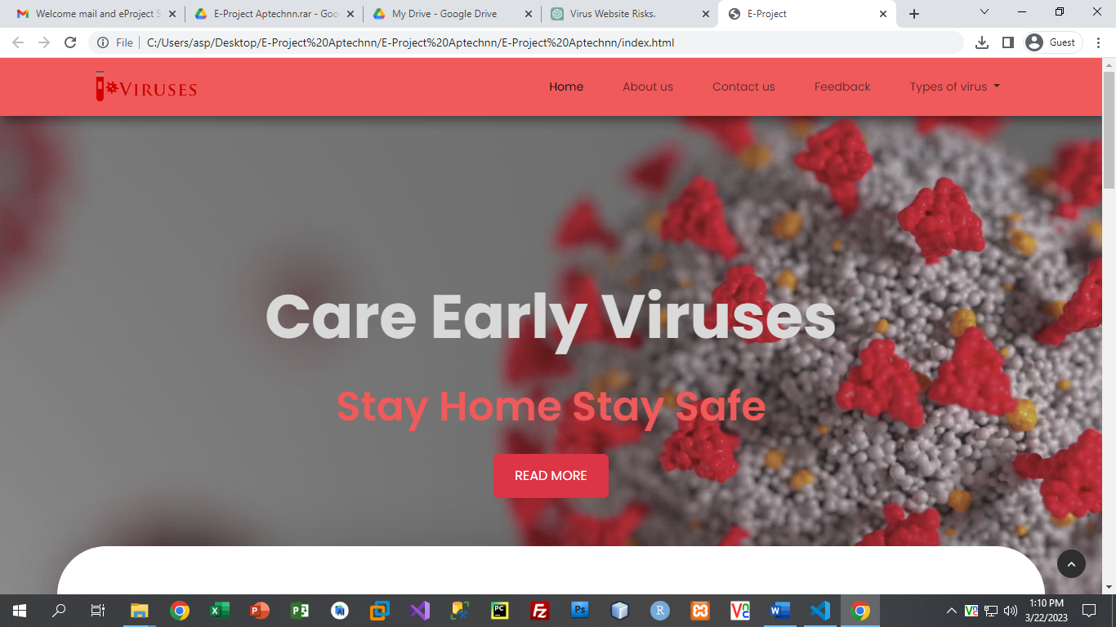

NAVBAR:

Menu:

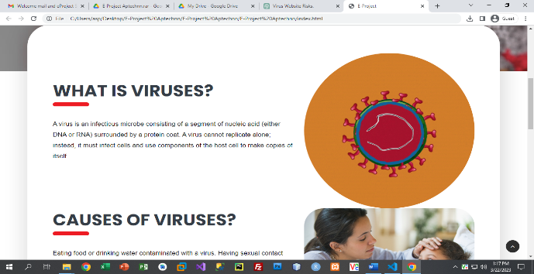 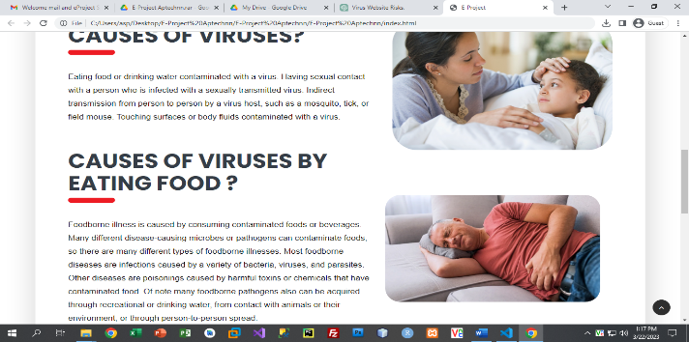

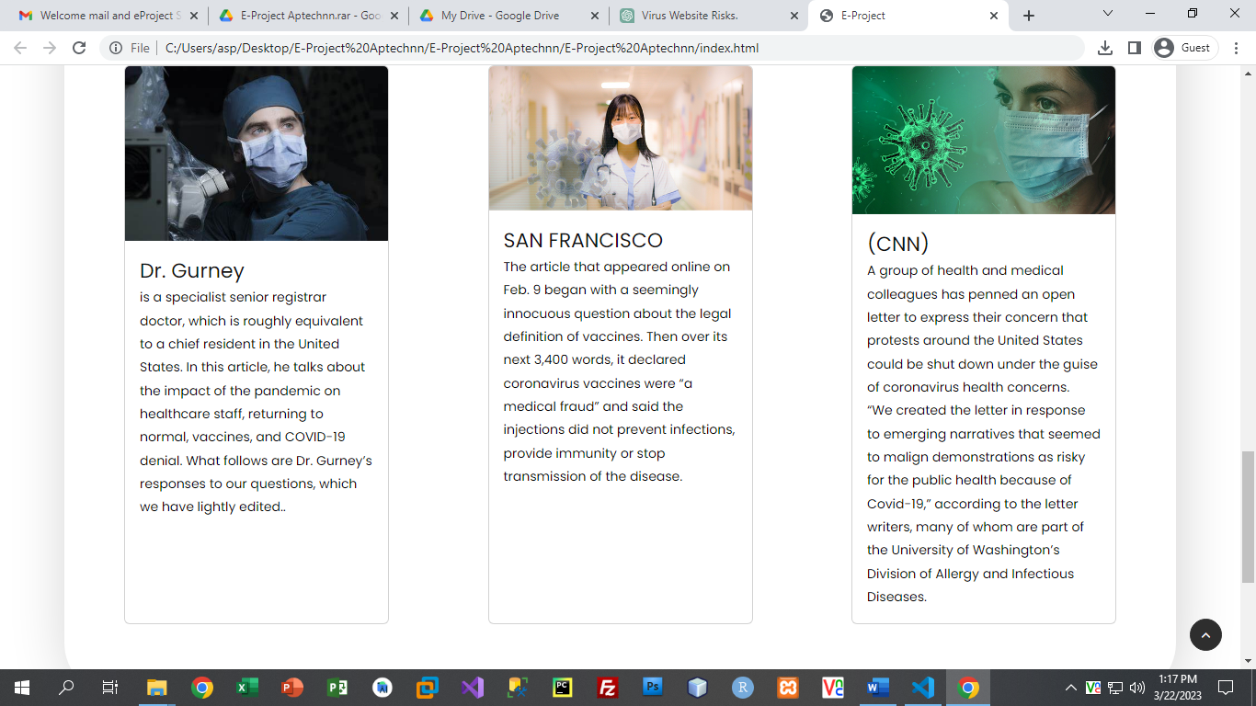

ABOUT US:

PIPP

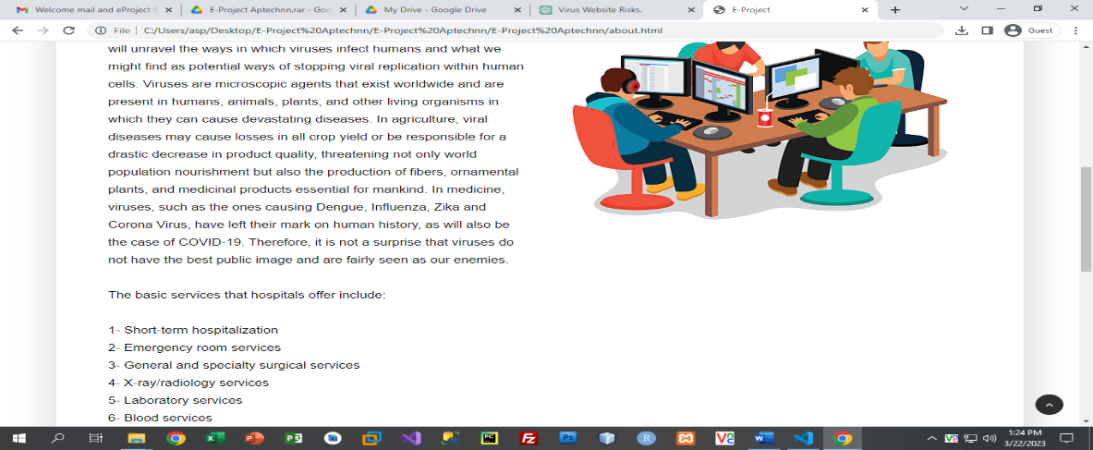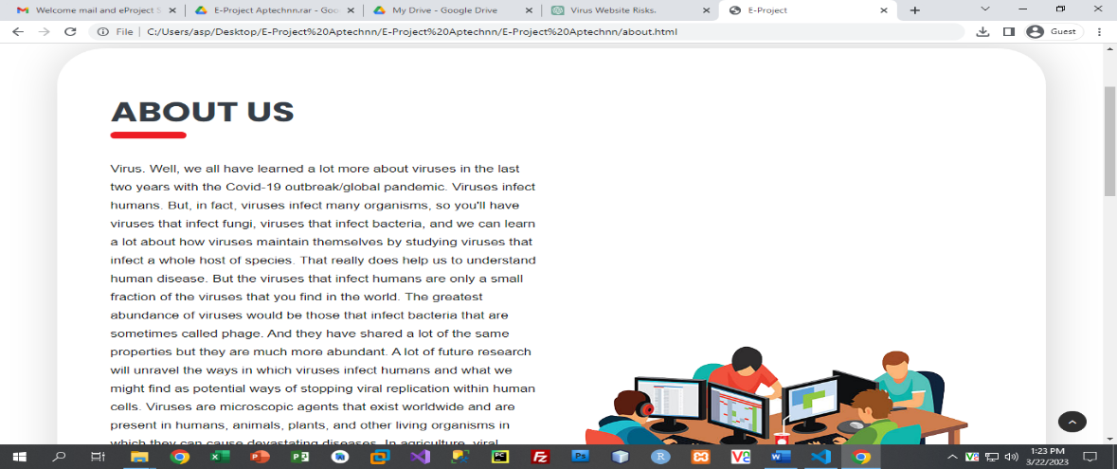

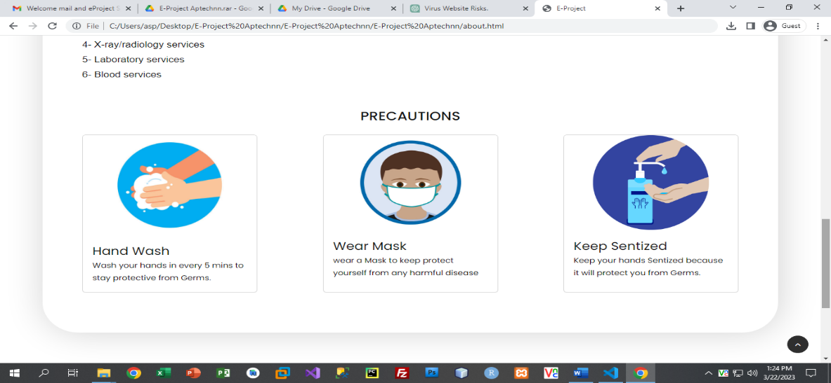

CONTACT US

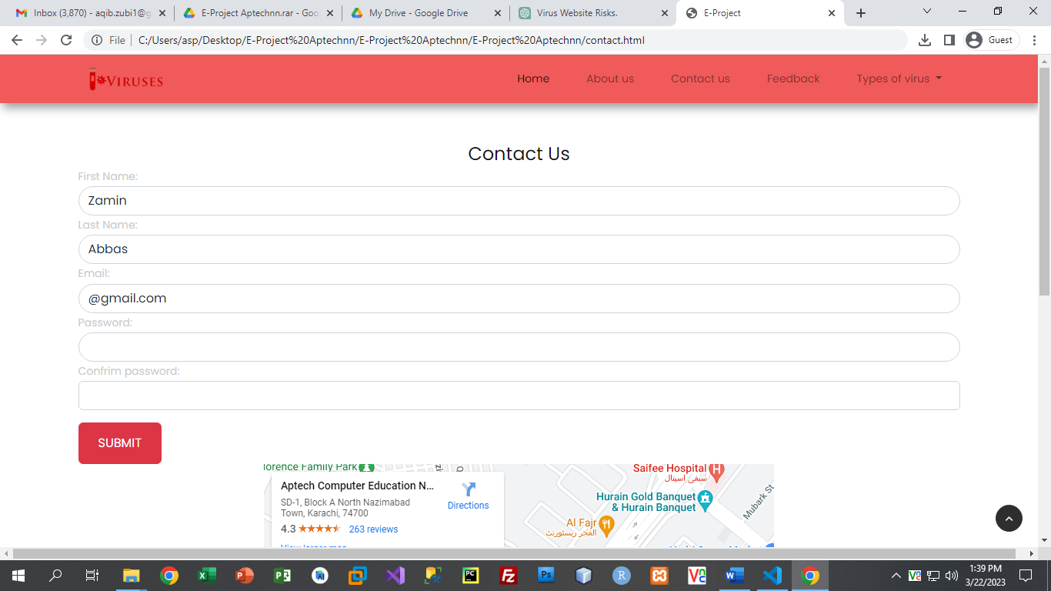

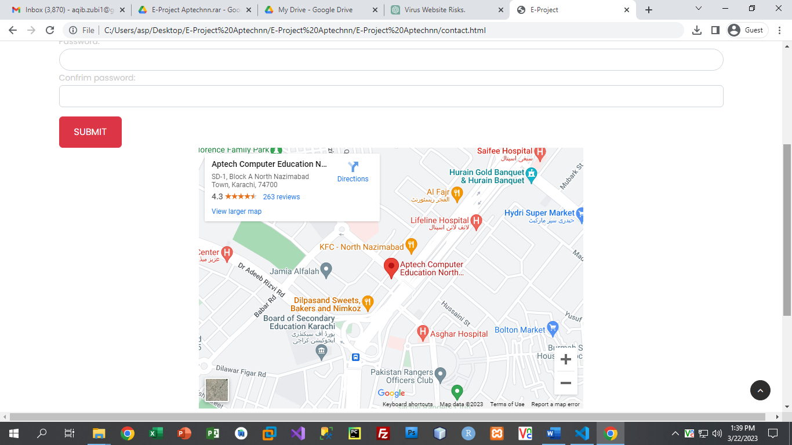

FEEDBACK US

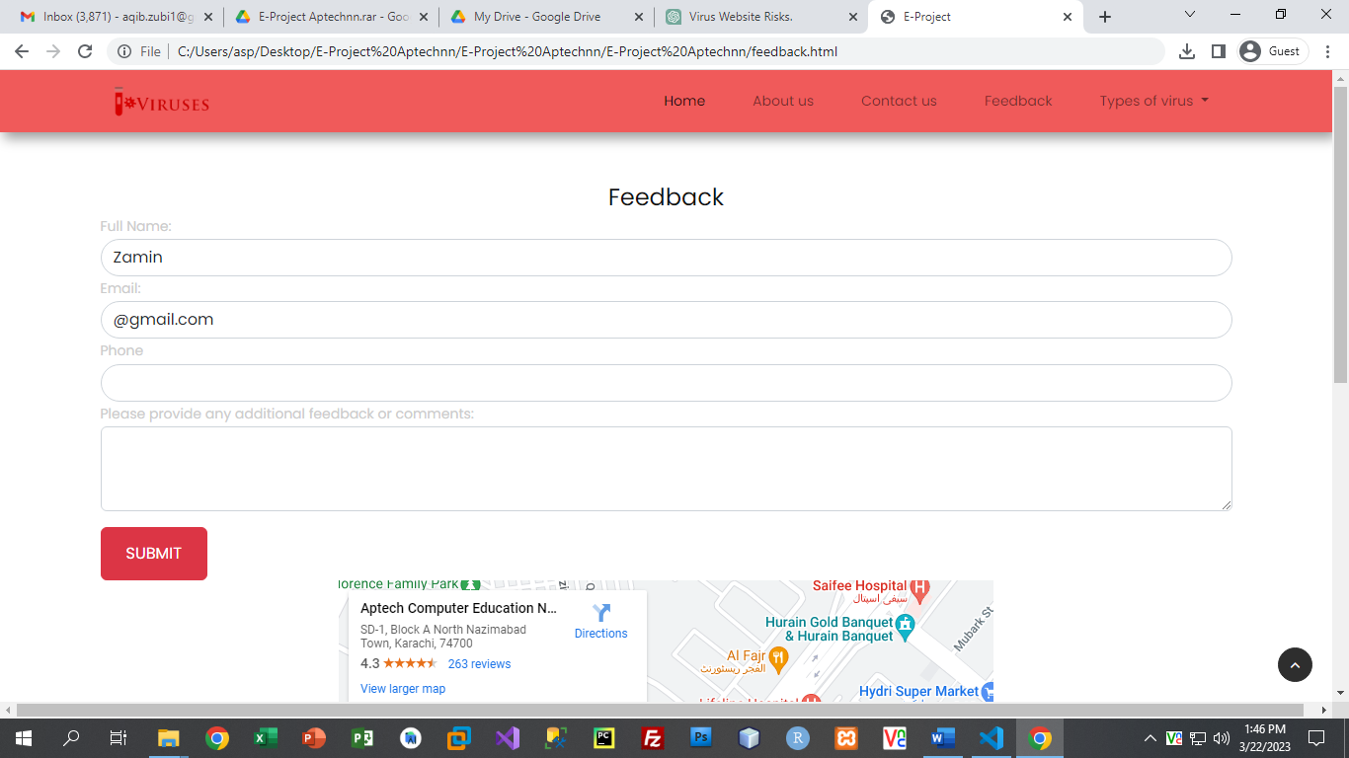

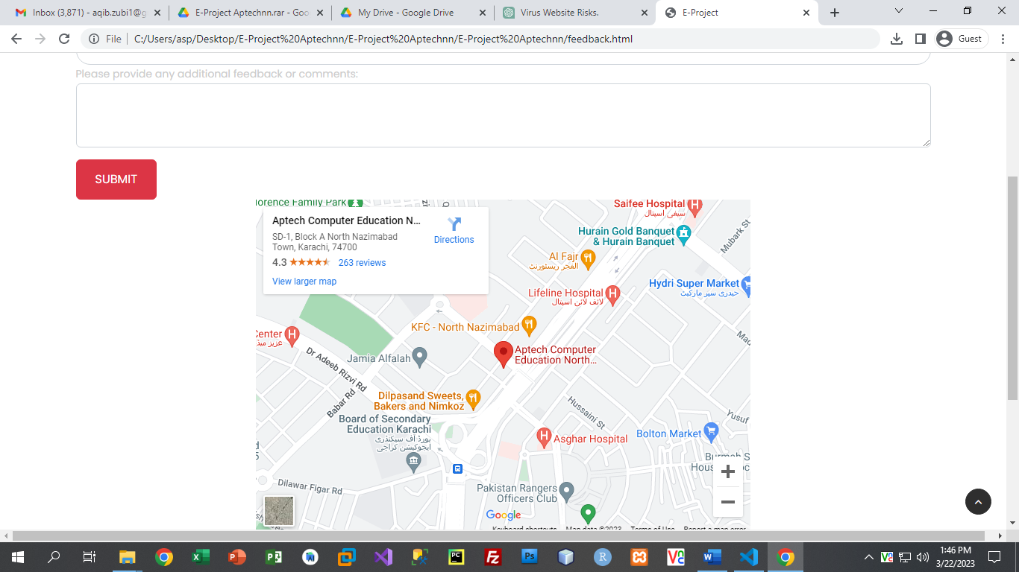

TYPES OF VIRUSES

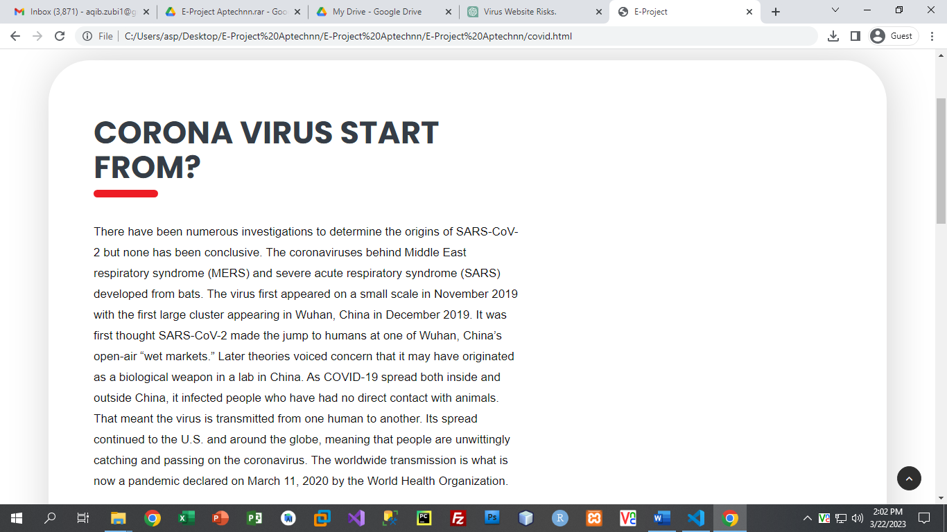 **1: CORONA VIRUS**

CONTENT

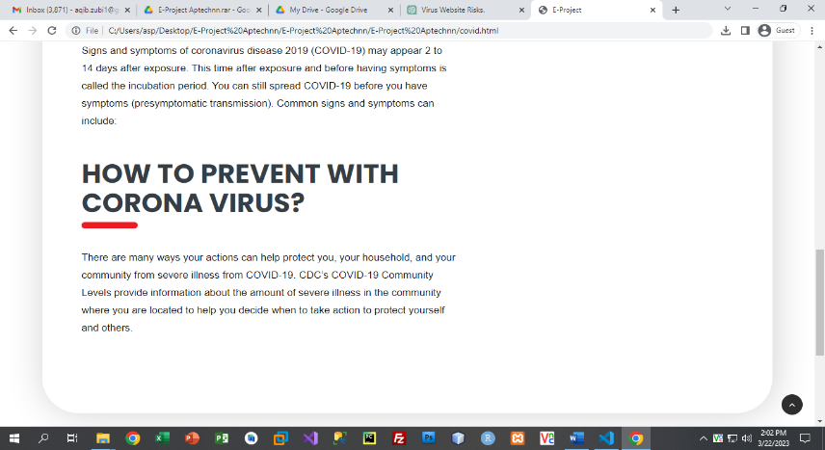

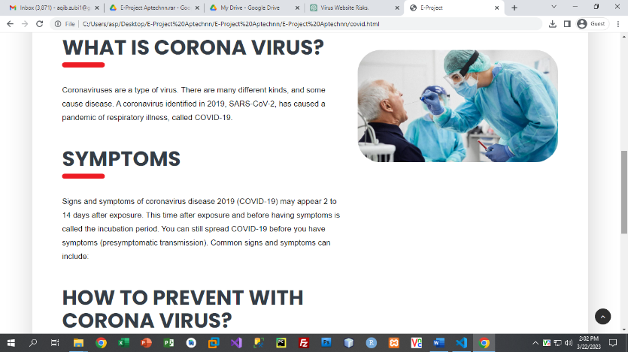

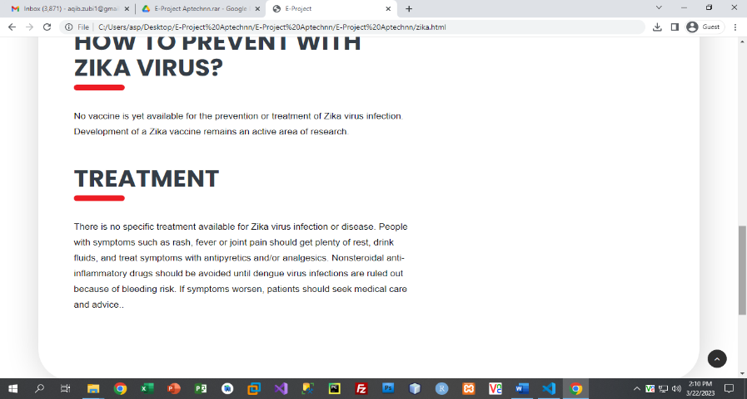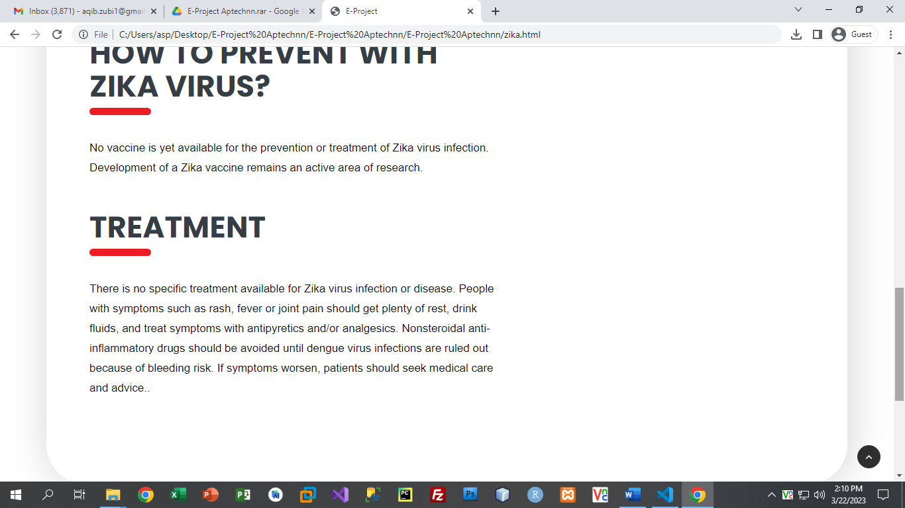**2: ZIKA VIRUS**

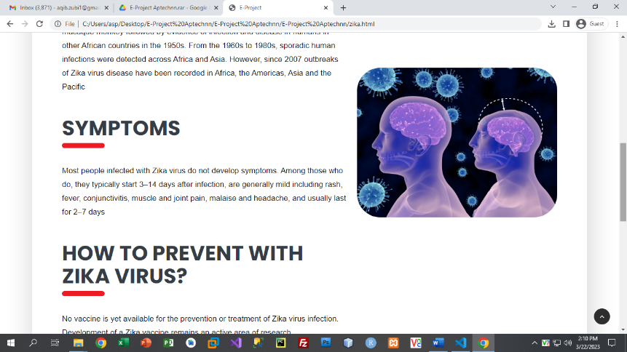

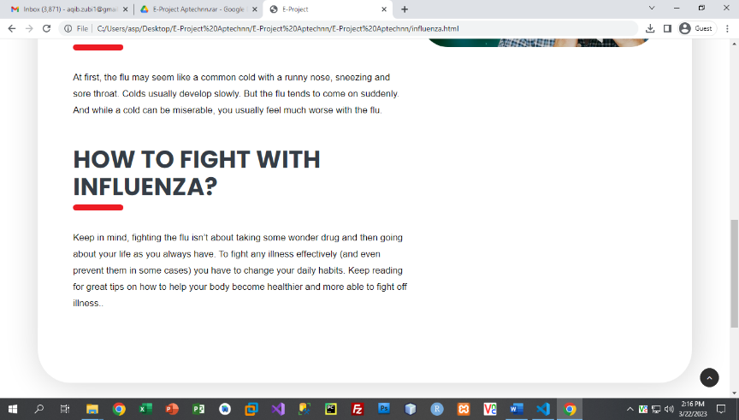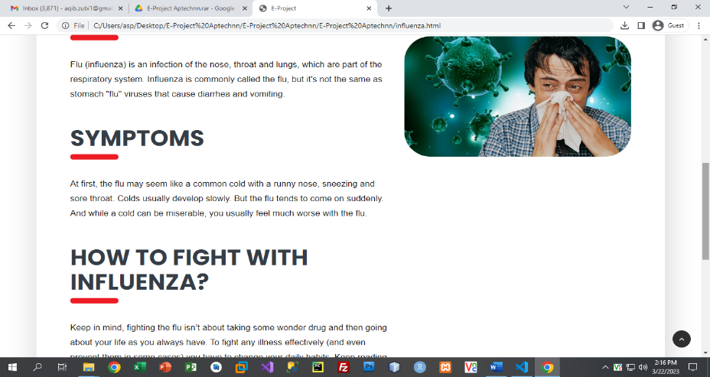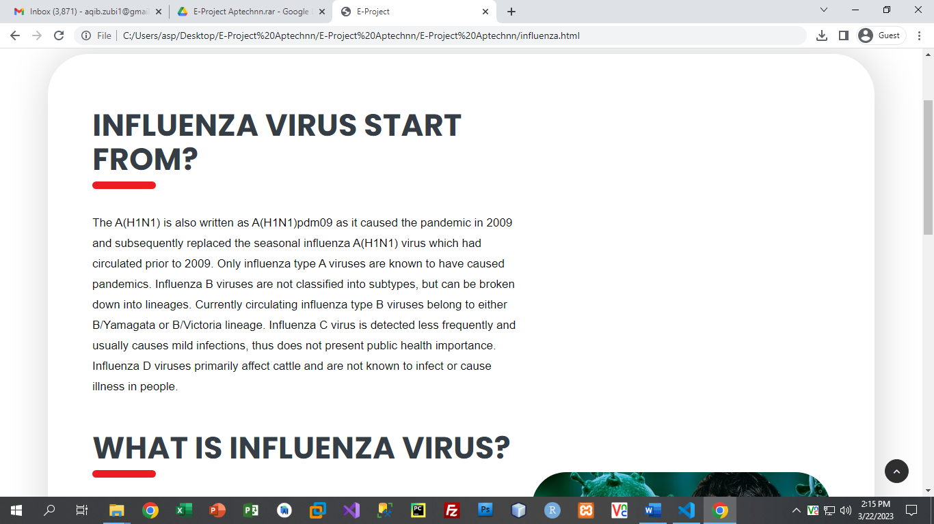**3: INFLUENZA VIRUS**

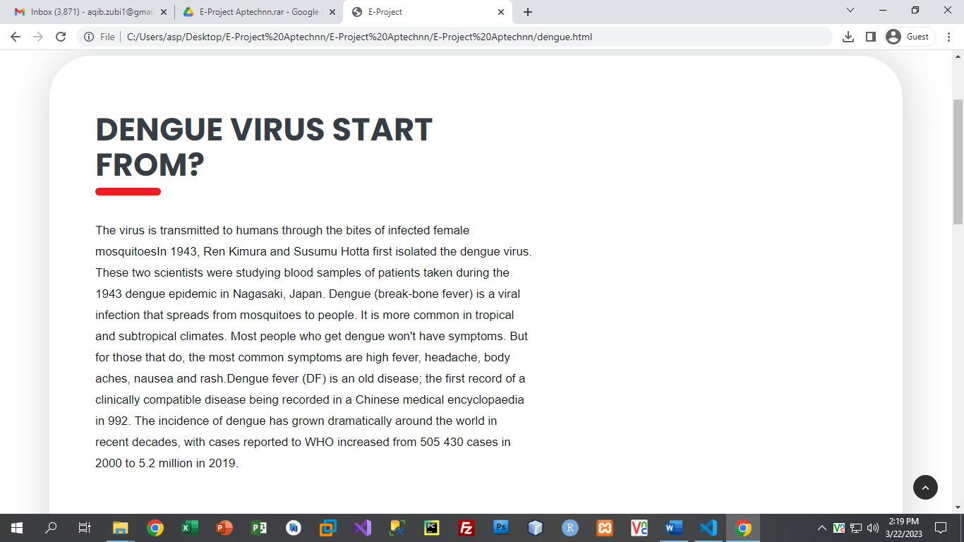 **4: DENGUE VIRUS**

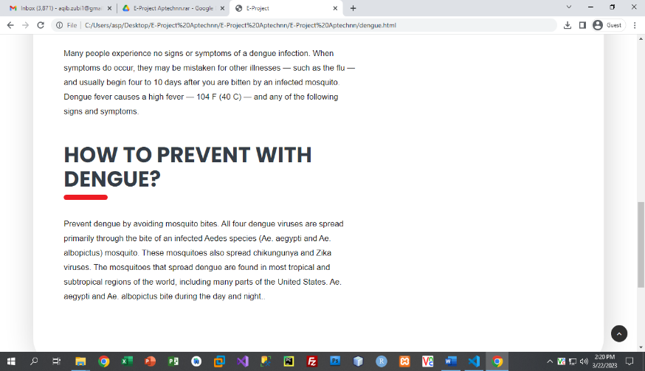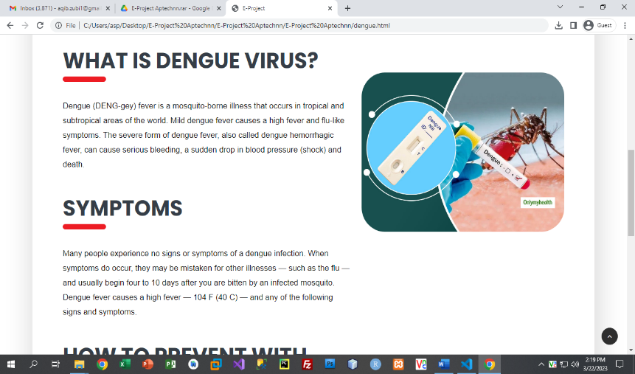

FOOTER:

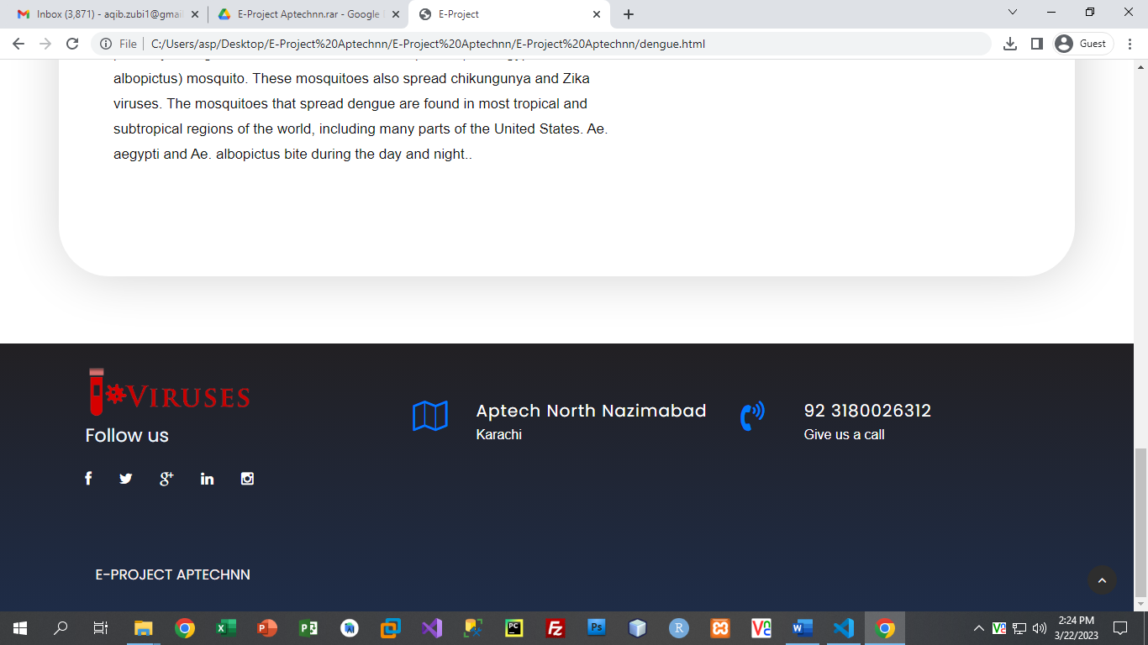

***TASK SHEET REVIEW 2***

|  |  |  |  |  |  |  |
| --- | --- | --- | --- | --- | --- | --- |
| Project Ref. No.: eP/Advertisement Portal Management System/01 | | Project  title | Date of Preparation of Activity Plan | | | |
| No | Task | Nexus  Aquarium | Actual | Actual | Team-mate | Status |
| Start Date | Days | Names |
| 1 | Build Home, Visit Page | 24/feb/23 | 1 | Zamin, Aqib | Complete |
| 2 | Build  Menu,  Product page | 27/feb/23 | 1 | Zamin | Complete |
| 3 | Build Testimonials page | 3/mar/23 | 3 | Aqib ,zamin | Complete |
| 4 | Build , login Page and content | 6/mar/23 | 7 | Zamin | Complete |
| 5 | Found pictures | 8/mar/23 | 2 | Aqib,  Zamin,  Hadi and Affan | Complete |
| 6 | Begin Code  JavaScript for and service page | 12/mar/23 | 3 | Aqib, Zamin, Hadi | Dropout |
| 7 | Begin Code  JavaScript for New Arrivals ,login page | 14 /mar/23 | 3 | Zamin | Complete |

|  |  |  |  |  |  |  |
| --- | --- | --- | --- | --- | --- | --- |
| 8 | Begin Code  Support For  Browsers and content |  | 19/mar/23 | 4 | Aqib and Zamin | Complete |
| 9 | Check Progress and Assign New Tasks | Every Alternative Day | - | Aqib | Complete |

***TASK SHEET REVIEW 3***

|  |  |  |  |  |  |  |
| --- | --- | --- | --- | --- | --- | --- |
| Project Ref. No.: eP/Advertisement Portal Management System/01 | | Project title | Date of Preparation of Activity Plan | | | |
| No | Task | Durable Furniture | Actual  Start Date | Actual  Days | Team-mate  Names | Status |
| 1 | Check color  format, size,  JavaScript, Bootstrap, CSS  responsive in the Home page create Navbar and logo | 25/feb/23 | 2 | Aqib and Zamin | Complete |
| 2 | Check color  format, size,  JavaScript, Bootstrap, CSS  responsive in  Menu,Products | 28/feb/23 | 2 | Aqib | Complete |
| 3 | Check color  format, size,  JavaScript,  responsive in  Portfolio, arrival page. | 02/mar/23 | 4 | Zamin | Complete |
| 4 | Write a  developer guide and web content | 20/mar/23 | 9 | Zamin and Aqib | Complete |
| 5 | Write user  Manuals |
| 6 | Overall  inspection of the project | 22/march/23 | 1 | Aqib, Zamin, Affan and Hadi | Complete |